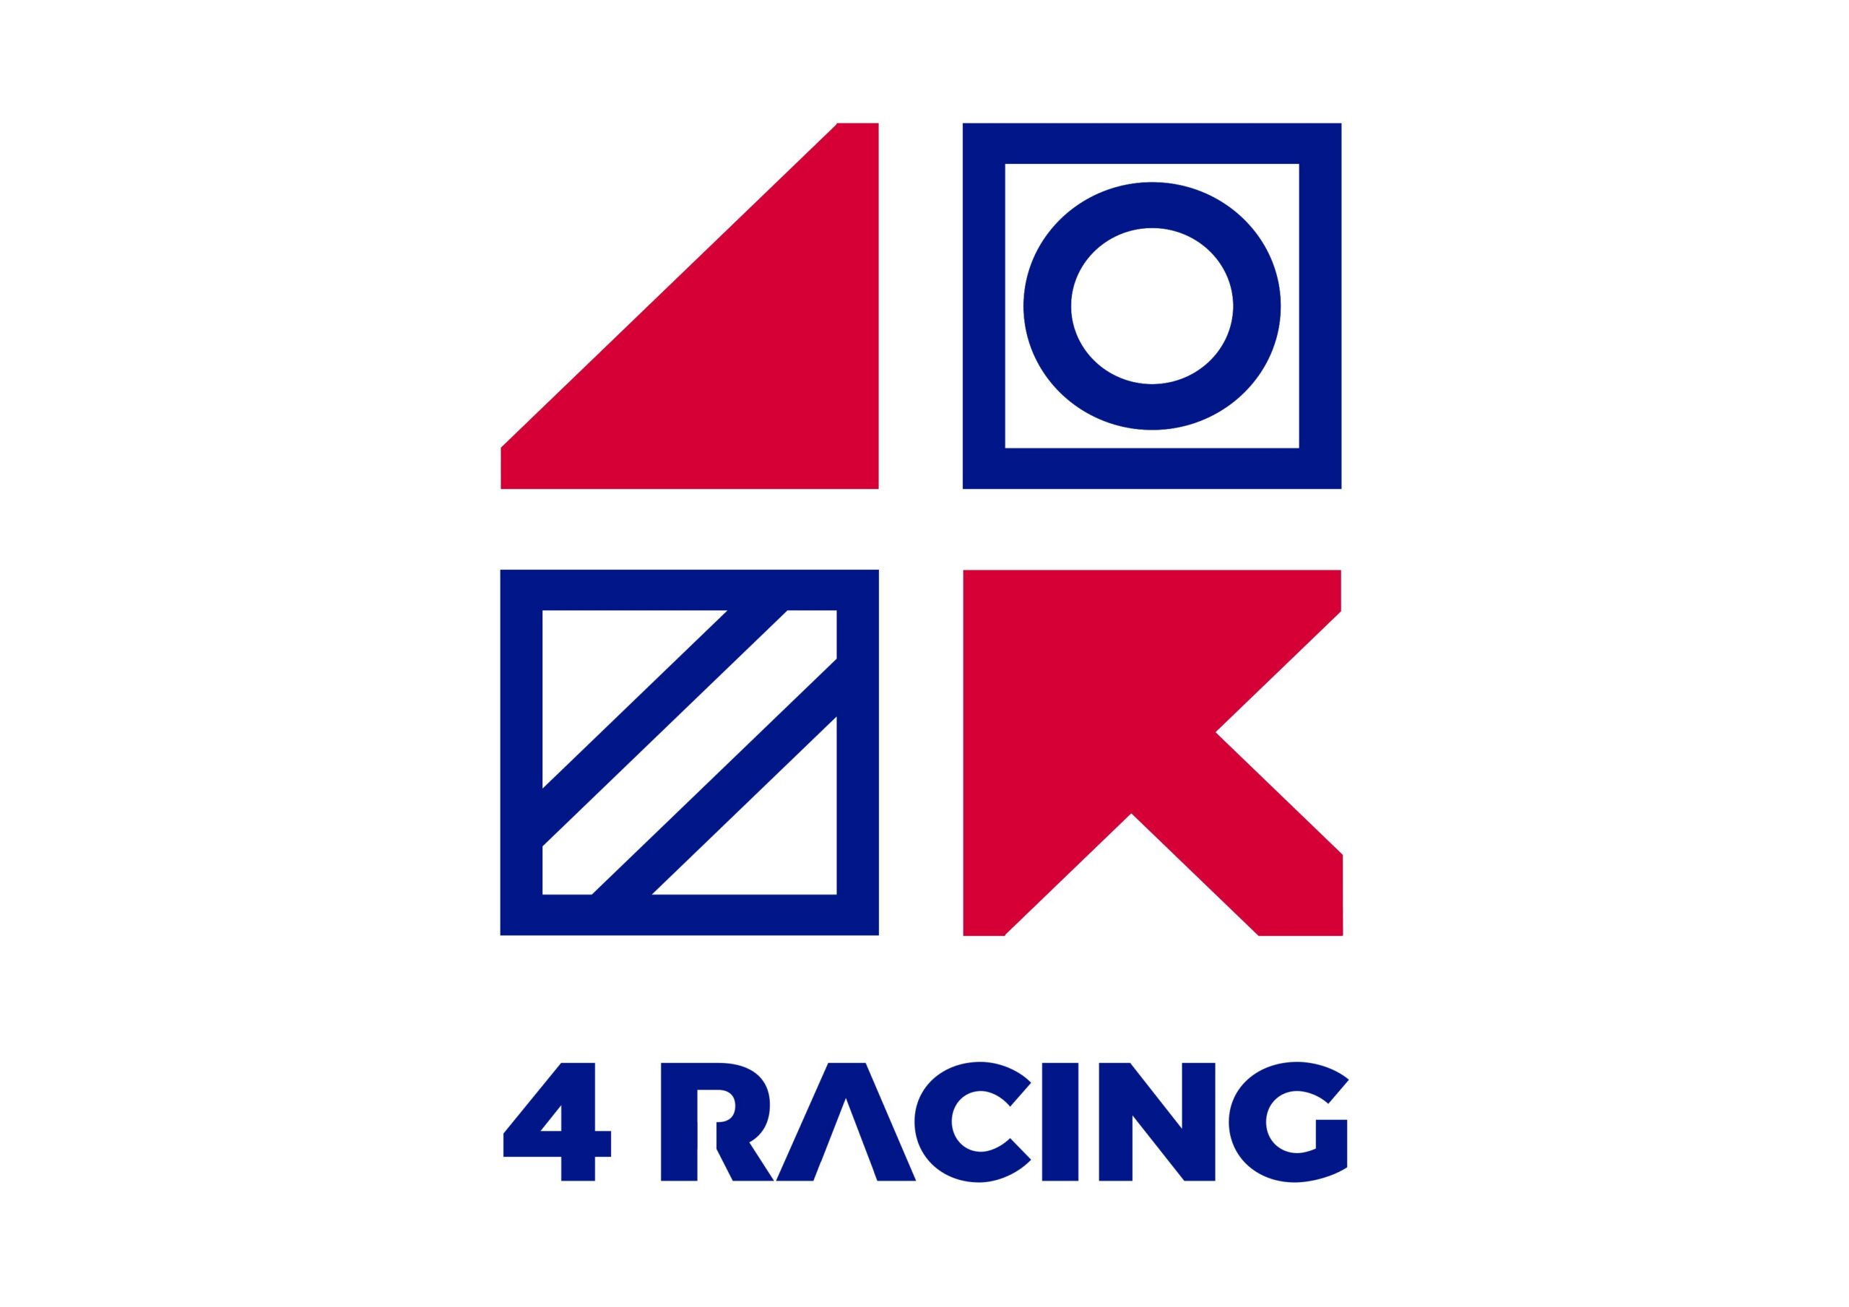

4RACING ANNOUNCES SIGNIFICANT OUT OF CYCLE STAKES INCREASE ACROSS THE EASTERN CAPE AND HIGHVELD

Johannesburg, South Africa - 4Racing today announced a substantial increase in stakes money across its Eastern Cape and Highveld regions, as part of a renewed investment in the growth and sustainability of horse racing in South Africa.

This significant out-of-cycle increase, to be applied over the next 5 months, totals R22 million, with the Eastern Cape stakes pot increase taking effect from 1 October 2026, and the Highveld programme boosted from 1 November 2026. The increases will be effective through to February 2027. Details for March, April and beyond will be confirmed in due course.

The 4Racing Owner Incentive will be discontinued. This will take effect in the Eastern Cape from 1 October and on the Highveld from 1 November. All other incentives remain unchanged.
“This is a massive investment in the future of racing,” said Patrick Duff, CEO at 4Racing. “Owners are a key stakeholder in the industry, and we want them to see tangible reasons to buy, race and stay in racing. This is about giving owners more chances to earn, coupled with a better overall experience in racing.”

Grooms
In addition to 4Racing’s current contribution to the Grooms of our industry, the portion of the stakes allocated to grooms will increase from 1% to 2%, effective from 1 October 2026.

What's Changing
From October 2026, 4Racing’s stakes structure will focus on targeting races that matter most to owners starting off and building a string, namely maiden and juvenile races, while also providing a spread across the open divisions and top ups to respective feature races where applicable.

Representative examples of the increase include:

Highveld

Category | Current | New
Maiden (In Season) | R120,000 | R170,000
Juvenile (In Season) | R150,000 | R200,000
Maiden Juvenile (In Season) | R130,000 | R185,000
Minimum (Off Season) | R80,000 | R100,000
Minimum (In-Season) | R80,000 | R120,000

Eastern Cape*

Category | Current | New
Maiden | R84,000 | R100,000
Juvenile | R94,000 | R106,000
Maiden Juvenile | R88,000 | R100,000
Minimum | R78,000 | R86,000

The full revised stakes schedule for each race category will be released in due course.

*Bear in mind that Eastern Cape stakes are year round and Highveld has in Season and out of Season stakes levels.
Effective Dates:

- Eastern Cape: stakes increase effective 1 October 2026
- Highveld: stakes increase effective 1 November 2026
- Duration: both increases run through the balance of the season to February 2027, with full-season stakes schedules to be confirmed prior.

ENDS.

Bet On Us with TAB at www.tab.co.za, or our social media pages #TABSouthAfrica on Facebook, Instagram and X.

To stay up to date with the latest event information, please visit our social media pages @4Racing on Facebook and Instagram. For race replays and other additional content, please visit the www.racingtoday.co.za website or app and social media platforms on Facebook, Instagram and X.

About 4Racing
4Racing is South Africa’s largest horse racing operator, responsible for the management of Turffontein, Vaal and Fairview racecourses, and operates the national TAB totalisator network, the country’s oldest and most extensive tote betting system. www.tab.co.za

For media enquiries, please contact:
Robyn Louw
robynl@4racing.com
079 394 3088

